Name: ____________________________ Date: __________
The Little Prince – Vocabulary Test

astonishment complex disheveled enormous ermine
extinct obedience reproach vanity etiquette
absurd balderdash conceited dejection ephemeral

impregnable peevish resound retort stately

voluminous

Directions: Read each description and choose a vocabulary term to best describe it. Explain why you chose the word.
Last Saturday was a terrible day for me. Not only had I forgotten to set my alarm to wake up by 7 for practice, but I also forgot to wash my uniform. Coach was frustrated with me and I was frustrated with myself. It put me into a terrible mood.
Word: _________________
Explanation: _________________________________________________________________
____________________________________________________________________________________________________________________________________________________________

On our hike up the mountain, we came upon a hollow, cave-like area. My little brother kept yelling into the crevice so that he could hear his own voice yell back. He actually thought someone else was mimicking him!
Word: _________________
Explanation: _________________________________________________________________
____________________________________________________________________________________________________________________________________________________________

I had trouble making sense of what he was saying. He kept speaking in circles and trying to explain himself but I couldn’t follow what he was saying. The part I did understand was certainly not believable!
Word: _________________
Explanation: _________________________________________________________________
____________________________________________________________________________________________________________________________________________________________

All she ever does is talk about herself. She is so full of pride but not in a good way! I wish she could be more humble.
Word: _________________
Explanation: _________________________________________________________________
____________________________________________________________________________________________________________________________________________________________

When my mom told me that we had to move away from my hometown to the other side of the country, I was miserable. Sad isn’t even a strong enough word to explain how I felt.

Word: _________________
Explanation: _________________________________________________________________
____________________________________________________________________________________________________________________________________________________________

Directions: From the box below, choose an antonym to match to each vocabulary word.

small simple organized eternal
shabby logical misbehavior living

complex: ______________ disheveled: __________________
ephemeral: ________________ enormous: ___________________
stately: _________________ absurd: _________________
extinct: __________________ obedience: __________________

Directions: Using the vocabulary term and topic provided, generate a sentence that explains the meaning of the word.
conceited / One Direction
__________________________________________________________________________________________________________________________________________________________________________________________________________________________________________

impregnable / prison
__________________________________________________________________________________________________________________________________________________________________________________________________________________________________________

astonishment / report card
__________________________________________________________________________________________________________________________________________________________________________________________________________________________________________

reproach / iPad
__________________________________________________________________________________________________________________________________________________________________________________________________________________________________________
Directions: Match each word to a correlating image.
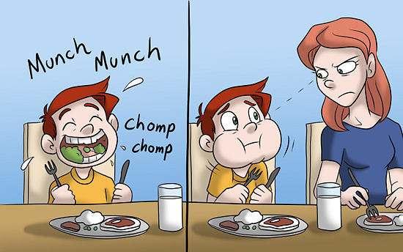
ermine

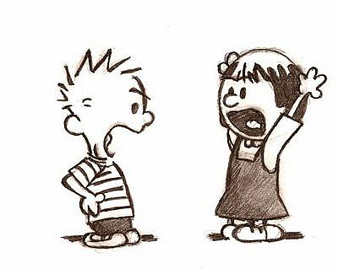

etiquette

voluminous

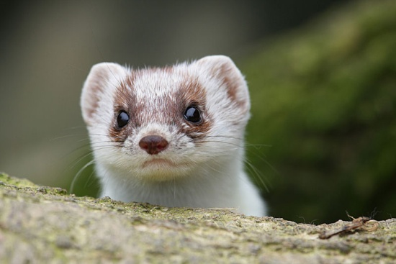
retort

Extra Credit:
Generate a descriptive sentence (with adjectives and conjunctions). For each vocabulary word you can sensibly add to the sentence, you will receive a bonus point!
________________________________________________________________________________________________________________________________________________________________________________________________________________________________________________________________________________________________________________________

