Name: ________________________________ Date: _________

**LP Vocabulary Quiz – Chapters 12-18**

Match the word to the meaning by writing the matching number on the line.

absurd___ a. nonsense, senseless talk or writing

balderdash___ b. unconquerable

conceited___ c. depression, lowness of spirits

dejection___ d. strange, foolish, not logical

ephemeral___ e. fleeting, short-lived

impregnable ___ f. vain, full of one’s self

----------------------------------------------------------------------------

peevish___ g. roomy, of ample size, fullness

resound___ h. irritated, cranky

retort___ i. grand, majestic

stately___ j. to reply to with wit

voluminous ___ k. to echo

Choose an image from the attached page to represent each word. Paste it in the box and explain why you chose the picture. Show how the picture relates to the word. You can be creative. Just show that you understand the meaning of the word.

peevish conceited

____________________________ ___________________________

____________________________ ___________________________

____________________________ ___________________________

____________________________ ___________________________

____________________________ ___________________________

ephemeral retort

____________________________ ___________________________

____________________________ ___________________________

____________________________ ___________________________

____________________________ ___________________________

____________________________ ___________________________

C:\Users\bradley\AppData\Local\Microsoft\Windows\Temporary Internet Files\Content.IE5\JRI40K2M\MC900215486[1].wmf 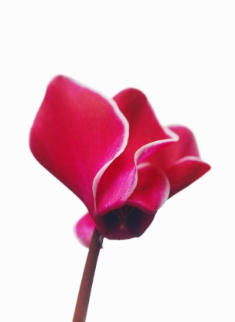

C:\Users\bradley\AppData\Local\Microsoft\Windows\Temporary Internet Files\Content.IE5\JRI40K2M\MC900140687[1].wmf 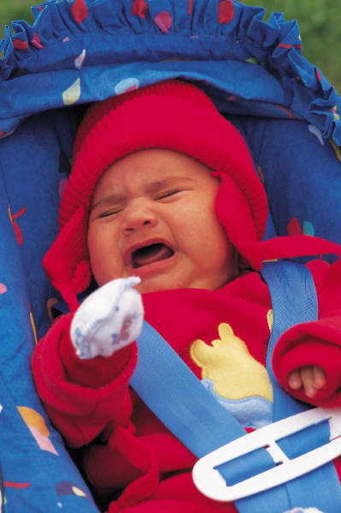

C:\Users\bradley\AppData\Local\Microsoft\Windows\Temporary Internet Files\Content.IE5\JRI40K2M\MC900383342[1].wmf C:\Users\bradley\AppData\Local\Microsoft\Windows\Temporary Internet Files\Content.IE5\2YO0JVGA\MC900078751[1].wmf