Name: ____________________________ Date: __________
The Little Prince – Story Board Project
Directions:
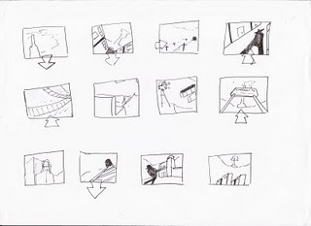
You will illustrate, and explain in well-written sentences, 7 major events from The Little Prince in sequential order. Begin by writing one important event per notecard. After you arrange the notecards in order, you will draw your images.

Once you finish the assignment, you will act out each important event you chose for your classmates.

