Name: ____________________________________ Date: ___________
Star of David Symbolism – Number the Stars
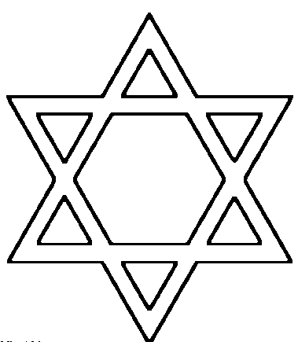
________________

_______________ ______________

______________ _______________

________________

Ellen
Unity or Togetherness
Spirituality
Triumph or Victory
Bravery or Courage
Freedom
Growth or Progress

