Seedfolks

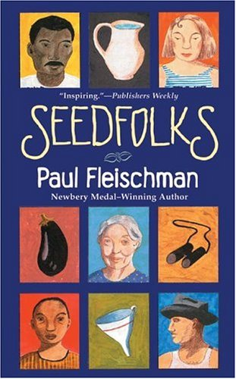
Intro through Leona

Name: ______________________________________________

Word List
Syllable Types
closed photograph janitors
open before country
v-e vacant stood
r-controlled focused suppose
double-vowel stern thrive teetered completely
perhaps sprouted
offered between
remember scouted
Cleveland

Exceptions: definite garden
Word Study 1
Give examples of words from the list that contain open syllables. Highlight or circle the open syllables.
_____________ _____________ ___________
_____________ _____________ ___________

Give examples of words from the list that contain double vowels. Highlight or circle the double-vowel syllables.
_____________ _____________ ___________
_____________ _____________ ___________

Give examples of words from the list that have vowel-consonant-e syllables. Highlight or circle the v-e syllables.
_____________ _____________ ___________
_____________ _____________

Word Study 2
Give examples of words from the list that have r-controlled syllables. Highlight or circle the r-controlled syllable.
_____________ _____________ ___________
_____________ _____________ ___________

Write and mark up the 2 exceptions:

_____________ _____________

Mark-up the following words:

focused stern supposed

remember between thrive

Tracing

photograph __________

offered __________

country __________

________ __________

Vocabulary
Use the dictionary (or dictionary.com) to look up and write the meaning of each word. Then generate a detailed sentence using the word. Add a visual cue.
teeter
meaning: ___________________________________
Sentence: __________________________________
____________________________________________________________________________________
visual cue:

vacant
meaning: ___________________________________
Sentence: __________________________________
____________________________________________________________________________________
visual cue:

Word Application
Choose 3 words from your list. Use each word in a separate sentence. Highlight the word you used in the sentence.
**Be sure your sentence contains: Caps, puncs, a conjunction, and adjectives**
_____________________________________________________________________________________________________________________

_____________________________________________________________________________________________________________________

_____________________________________________________________________________________________________________________

Visualizing and Verbalizing
Imaging

Comprehension
Why do you think Anna makes a judgment about Kim? How does she feel when she realizes her error?
______________________________________________________________________________________________________________________________
What does Wendell mean when he says, “and a little child shall lead them” (page 12)?
______________________________________________________________________________________________________________________________
What does Gonzalo mean when he says, “the older you are, the younger you get when you move to the United States” (page 13)?
______________________________________________________________________________________________________________________________

What important role does Leona play in the development of the city lot?
______________________________________________________________________________________________________________________________
__________________________________________

