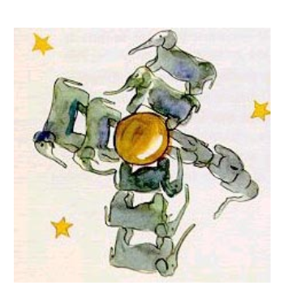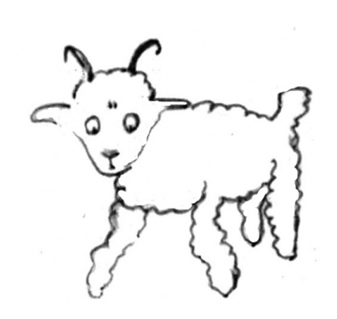
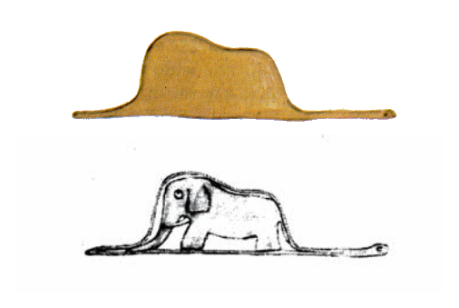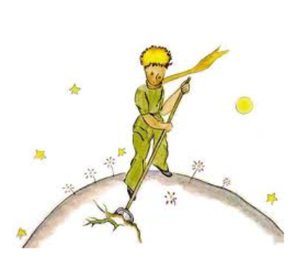

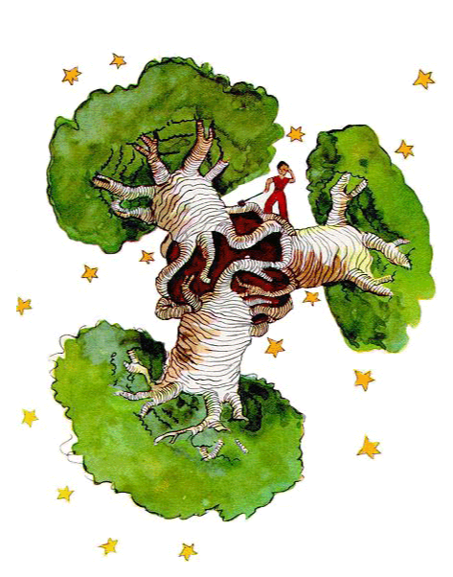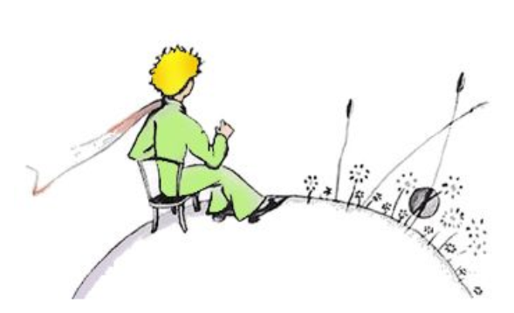
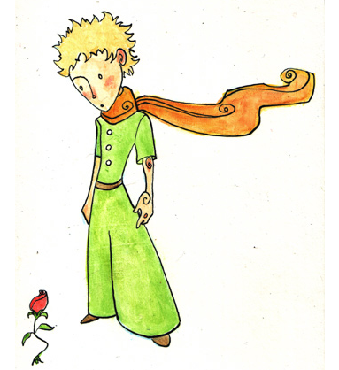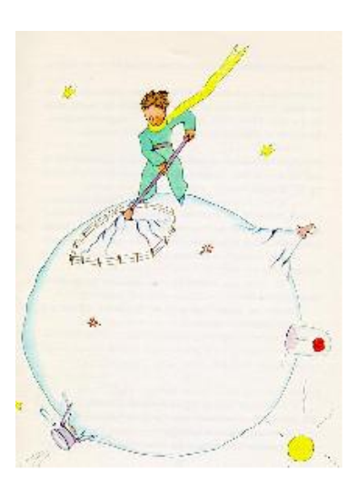
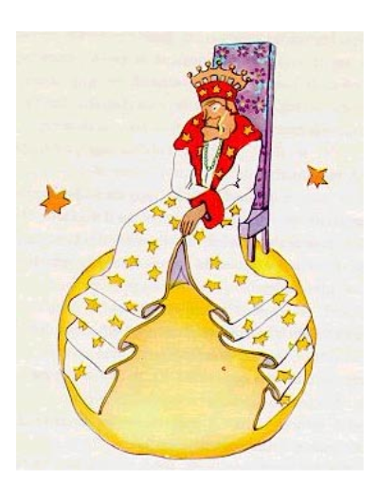

Name: ___________________________ The Little Prince Date: ____________

“Then I drew the inside of the boa constrictor, so the grownups could understand. They always need explanations. That is why I abandoned, at the age of sic, a magnificent career as an artist.”

“The idea of the herd of elephants made the little prince laugh.”

“He looked at it carefully, and then said, ‘No. This one is already quite sick. Make another.’”

“But if it’s the seed of a bad plant, you must pull the plant up right away, as soon as you can recognize it…When I drew the baobabs, I was inspired by a sense of urgency.”

“For a long time your only entertainment was the pleasure of sunsets…on your tiny planet, all you had to do was move your chair a few feet.”

“He carefully raked out his active volcanoes.”

“If someone loves a flower of which just one example exists among all the millions and millions of stars, that’s enough to make him happy when he looks at the stars.”

“The first (planet) was inhabited by a king.” He wanted to rule over everything.

