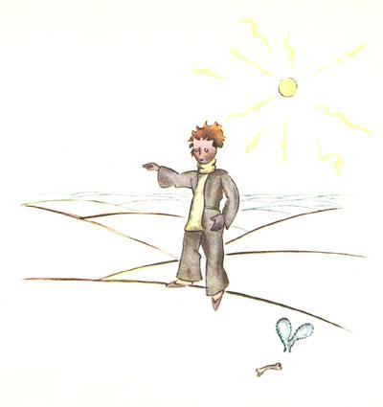

Name: _________________________
absurd
balderdash
conceited
dejection
ephemeral
impregnable
peevish
resound
retort
stately
voluminous

Vocabulary
Word Meaning Sentence Visual Cue
Absurd | Ridiculous,  strange | Saying that you ate 10 bowls of ice cream is truly absurd.
Balderdash | Nonsense | What the media said about Justin Bieber is balderdash; he does not live in a hut in the jungle.
Conceited | Vain, proud, smug | The conceited lady stares at her reflection in the mirror all day.
Dejection | Sadness, misery | When her dog died, she was filled with dejection.
Ephemeral | Short-lived,  fleeting, brief | The life of a flower is ephemeral; it does not last forever.
Impregnable | Secure, unconquerable | The locks on the gate made the house seem impregnable.
Peevish | Irritable, cranky | She was peevish because she was tired and had not eaten.
Resound | Echo, resonate | The sounds of her cries will resound through the house.

Retort | Reply angrily, come back with verbally | With frustration, he retorted, “Well, you are just plain stupid!”
Stately | Dignified, majestic | The stately house stood on a hill, flanked by marble pillars.
Voluminous | Huge, roomy | The pants were voluminous; she should have gone with a smaller size.

Comprehension – V & V (sentence to sentence)
Directions: Color-code the excerpt from The Little Prince. Then, use Visualizing and Verbalizing techniques to illustrate and paraphrase. You will need to group relevant sentences together.

“It may well be that this man is absurd. But he is not so absurd as the king, the conceited man, the business man, and the tippler. For at least his work has some meaning. When he lights his street lamp, it is as if he brought one more star to live, or one flower. When he puts out his lamp, he sends the flower, or the star, to sleep. That is a beautiful occupation. And since it is beautiful, it is truly useful.”

Word Application

Choose 3 words from the word list. Use each one in a detailed sentence (with a conjunction) that shows the meaning of the term. Highlight or underline the word and circle the part of the sentence that shows the meaning.

__________________________________________________________________________________________________________________

__________________________________________________________________________________________________________________

__________________________________________________________________________________________________________________

