Wordlist
Vocabulary Terms

astonishment
complex
disheveled
enormous
ermine
extinct
obedience
reproach
vanity

sight words:
etiquette
Vocabulary
Word Meaning Sentence Visual Cue
Astonishment | Surprise, amazement | _____________  _____________  _____________  _____________
Complex | Many parts, difficult | _____________  _____________  _____________  _____________
Disheveled | Messy | _____________  _____________  _____________  _____________
Enormous | Huge, colossal | _____________  _____________  _____________  _____________
Ermine | A weasel whose brown fur turns white in the winter | _____________  _____________  _____________  _____________
Etiquette | Manners | _____________  _____________  _____________  _____________
Reproach | To express disappointment, criticism, blame | _____________  _____________  _____________  _____________
Vanity | Pride, conceit | _____________  _____________  _____________  _____________

Comprehension – V & V (sentence to sentence)
Directions: Color-code the excerpt from The Little Prince. Then, use Visualizing and Verbalizing techniques to illustrate and paraphrase. You will need to group relevant sentences together.

He could say no more because he was overcome with tears. Night had fallen. I had dropped my tools. I couldn’t have cared less about my hammer, my bolt, thirst or death. There was on a star, a planet, mine, the Earth, a little prince to be comforted! I took him in my arms and rocked him gently. I said to him, ‘The flower you love is in no danger… I shall draw you a muzzle for your sheep… I shall draw you a fence for your flower… I …’ I did not really know what to say to him. I felt very awkward. I did not know how to reach him, how to catch up with him… the land of tears is so mysterious.

Word Meaning

Match the word to its meaning. You will be challenged! Use a dictionary if necessary.

Etiquette a weasel with a color-changing coat

Reproach feeling of great surprise

Astonishment code of behavior, social expectations

Vanity untidy, disordered

Ermine very large in size, quantity or extent

Disheveled excessive admiration for one’s self

Enormous to express disapproval

Complex consisting of many different parts

Obedience dead, destroyed

Extinct compliance, respect, agreement

Use the word ‘etiquette’ in a sentence. Remember, etiquette is a noun, something you can have.
______________________________________________________________________________

The Little Prince

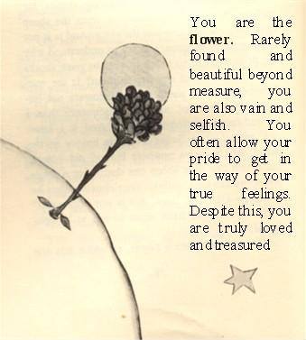

Chapters 6 - 10

Name: ______________

