Wordlist
Hard and Soft G and C

prince
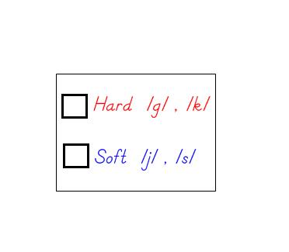
digested
gravely
succeeded
accident
exception
discouraged
region
grammar
cumbersome
perceived
gently
discovery
origin
scarcely
Hard and Soft ‘g’

Gg Gg
Hard /g/ sound as in ‘go’ when Soft /j/ sound as in ‘gem’ when ‘g’
‘g’ is followed by a, o or u. is followed by e, i or y.

Directions: Sort the words below into the appropriate column based on the sound the letter ‘g’ makes in the word.

Word Bank: digested discouraged region urgent grammar
pentagon stage engine goose detergent ginger gravely gently origin

Hard g: /g/ sound Soft g: /j/ sound
______________________ ______________________

______________________ ______________________

______________________ ______________________

______________________ ______________________

______________________ ______________________

______________________ ______________________

______________________ ______________________

______________________ ______________________
Hard and Soft ‘c’

Cc Cc
Hard /k/ sound as in ‘can’ when Soft /s/ sound as in ‘ice’ when ‘c’
‘c’ is followed by a, o or u. is followed by e, i or y.

Directions: Sort the words below into the appropriate column based on the sound the letter ‘c’ makes in the word.

Word Bank: currency succeeded accident country exception prince discouraged cumbersome perceived sincere electric discovery scarcely

Hard c: /k/ sound Soft c: /s/ sound
______________________ ______________________

______________________ ______________________

______________________ ______________________

______________________ ______________________

______________________ ______________________

______________________ ______________________

______________________ ______________________

______________________ ______________________
Vocabulary
Word Meaning Sentence Visual Cue
Abashed | Embarrassed | _____________  _____________  _____________  _____________
Etiquette | Rules of behavior, manners | _____________  _____________  _____________  _____________
Lugubrious | Mournful, gloomy | _____________  _____________  _____________  _____________
Reverie | Lost in thought,  Daydream | _____________  _____________  _____________  _____________
Dejection | Unhappiness,  Misery | _____________  _____________  _____________  _____________
Ephemeral | Short-lived, fleeting | _____________  _____________  _____________  _____________
Peal | Clang, ring, bell tones | _____________  _____________  _____________  _____________
Adornment | Decoration, embellishment | _____________  _____________  _____________  _____________

Comprehension – V & V (sentence to sentence)
Directions: Color-code the excerpt from The Little Prince. Then, use Visualizing and Verbalizing techniques to illustrate and paraphrase.

Thus I lived alone, with no one I could really talk to, until I had an accident in the Sahara Desert six years ago. Something broke down in my engine. And since there was neither a mechanic nor a passenger with me, I prepared myself for a difficult but what I hoped would be a successful repair. It was a matter of life or death for me. I had scarcely enough drinking water for a week.

The Little Prince
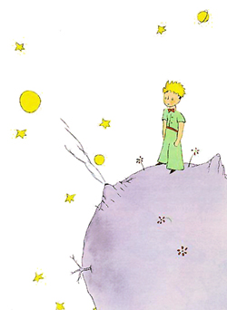

Chapters 1 – 5

Name: ______________

