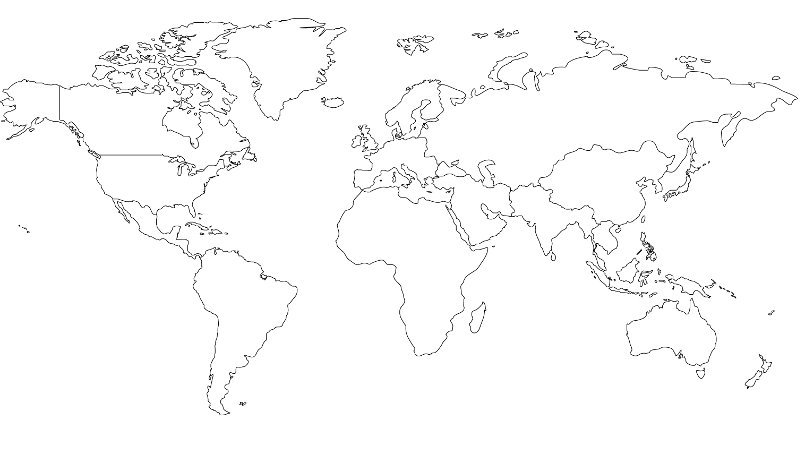
The Little Prince

North America Europe Asia

Africa
South America
Australia

The narrator flies his air plane over the Sahara Desert, but suddenly his engine breaks, and he lands in the desert. Though he nearly dies of thirst, he meets the Little Prince and learns from the prince the secret of life.
