Name: ______________________________ Date: ________

Seedfolks Project: Create Your Character

Directions: Just as you’ve always imagined, you will become part of the story, Seedfolks! For this assignment, you will illustrate yourself as well as 2-3 specific items that represent you, complete an Expanding Expression Tool, and a Character Study.

Think about:
-How would YOU contribute to the Seedfolks garden?
-What makes YOU special?
-What differences could you bring to light?

_______________________________________

Expanding Expression Tool

Topic: __________

O Group: _________________________
O Do: ____________________________________ __________________________________________
O Look Like: ______________________________
____________________________________________________________________________________
O Made Of: _______________________________ ____________________________________________________________________________________
O Parts:__________________________________ _________________________________________
O Where:_________________________________
O What else do you know: ___________________
_________________________________________
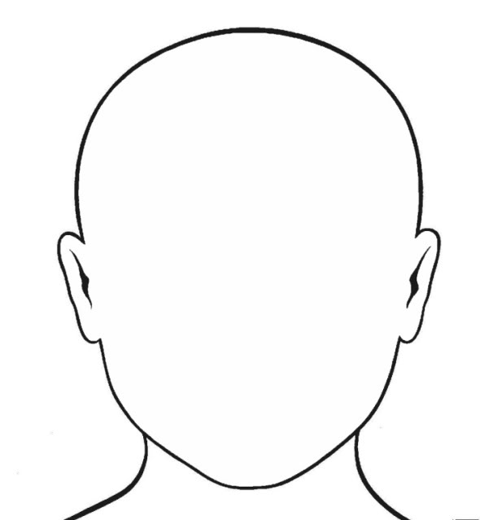

Character’s Name: __________________
Age: ___________
Ethnicity: _______________________________
Contribution: _____________________________ _____________________________________
Reason for Involvement: _______________________ _____________________________________
Effects of Association: ________________________ _____________________________________

