Name: ________________________________ Date: _____________
The Little Prince – Vocabulary ch. 6-10
astonishment complex disheveled enormous ermine
extinct obedience reproach vanity etiquette
Using the wordlist, complete the sentences with the appropriate term. Not all words will be used.

After tripping and landing in a puddle, the girl looked too _______________ so she needed to return home for a change of clothes.

With ______________, Ella stared at her mother. She did not believe the punishment fit the crime.

The math problem was too ______________; the girl could not solve it.

Jan decided that she wanted to teach her puppy _____________, so that he would behave better!

Using the topic and vocabulary term provided, generate a detailed sentence that shows the meaning of the word through example.

school / enormous
____________________________________________________________________________________________________________________________________________________

English Wolf / extinct
____________________________________________________________________________________________________________________________________________________

dinner / etiquette
____________________________________________________________________________________________________________________________________________________

color / ermine
____________________________________________________________________________________________________________________________________________________

Look at the images below. Choose an unused vocabulary term (vanity, astonishment) and apply it to a picture. Explain how the term is related to the image.
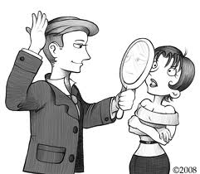
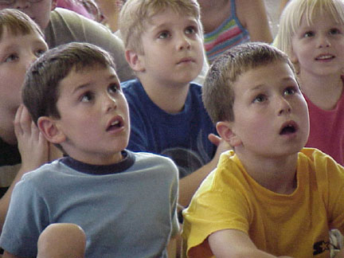

Word: _________________ Word: _________________
__________________ _________________
__________________ _________________
__________________ _________________
__________________ _________________
__________________ _________________
__________________ _________________

